**Meta-analysis of noble metal deposited CeO2and other metal oxide catalysts on aerobic oxidation of benzyl alcohol**

A comparative statistical test was performed on a small sample size of 17 noble metal based metal oxide catalysts to evaluate the effect of the nature of noble metal, particle size of noble metal particle, nature of support, temperature, time, Mass Transfer Limitations on the aerobic oxidation of benzyl alcohol.

A short comparison of the Nominal variables is given below

**Descriptive Statistics**

| **Descriptive Statistics** | | | | | | | | | | | |
| --- | --- | --- | --- | --- | --- | --- | --- | --- | --- | --- | --- |
|  | | **Solvent** | | **Support Type** | | **Noble Metal 1** | | **Noble Metal 2** | | **Dopant 1** | |
| Valid |  | 15 |  | 15 |  | 15 |  | 15 |  | 14 |  |
| Missing |  | 0 |  | 0 |  | 0 |  | 0 |  | 1 |  |
| Mean |  |  |  |  |  |  |  |  |  |  |  |
| Std. Deviation |  |  |  |  |  |  |  |  |  |  |  |
| Minimum |  |  |  |  |  |  |  |  |  |  |  |
| Maximum |  |  |  |  |  |  |  |  |  |  |  |
|  | | | | | | | | | | | |

**Correlation plot**

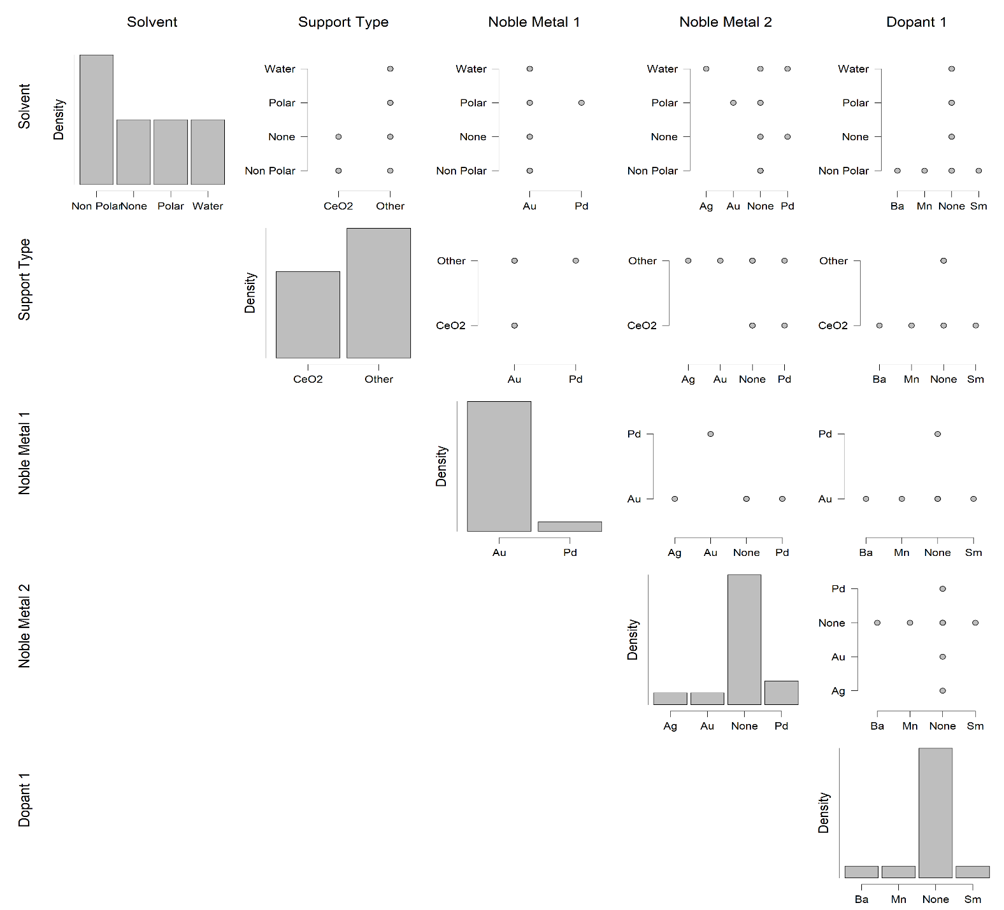

To investigate the correlation between particle size and catalyst conversion Student’s t test, ANOVA and Linear Regression analysis was performed

**Student’s t test**

| **Paired Samples T-Test** | | | | | | | | | | | |
| --- | --- | --- | --- | --- | --- | --- | --- | --- | --- | --- | --- |
|  | |  | |  | | **t** | | **df** | | **p** | |
| Dp |  | - |  | Conv. (%) |  | -6.673 |  | 14 |  | < .001 |  |
|  | | | | | | | | | | | |
|  | | | | | | | | | | | |

The Student’s t test on the correlation between particle size of noble metal (Dp) and the conversion of benzyl alcohol have shown a negative t value (-6.673) indicates that the mean value of the samples is less than the hypothesized mean. Also, as the p <0.05, the result can be considered significant.

**Linear Regression**

| **Model Summary - Conv. (%)** | | | | | | | | | |
| --- | --- | --- | --- | --- | --- | --- | --- | --- | --- |
| **Model** | | **R** | | **R²** | | **Adjusted R²** | | **RMSE** | |
| H₀ |  | 0.000 |  | 0.000 |  | 0.000 |  | 29.355 |  |
| H₁ |  | 0.061 |  | 0.004 |  | -0.073 |  | 30.405 |  |
|  | | | | | | | | | |

| **ANOVA** | | | | | | | | | | | | | |
| --- | --- | --- | --- | --- | --- | --- | --- | --- | --- | --- | --- | --- | --- |
| **Model** | |  | | **Sum of Squares** | | **df** | | **Mean Square** | | **F** | | **p** | |
| H₁ |  | Regression |  | 45.397 |  | 1 |  | 45.397 |  | 0.049 |  | 0.828 |  |
|  |  | Residual |  | 12018.336 |  | 13 |  | 924.487 |  |  |  |  |  |
|  |  | Total |  | 12063.733 |  | 14 |  |  |  |  |  |  |  |
|  | | | | | | | | | | | | | |
|  | | | | | | | | | | | | | |

| **Coefficients** | | | | | | | | | | | | | |
| --- | --- | --- | --- | --- | --- | --- | --- | --- | --- | --- | --- | --- | --- |
| **Model** | |  | | **Unstandardized** | | **Standard Error** | | **Standardized** | | **t** | | **p** | |
| H₀ |  | (Intercept) |  | 59.133 |  | 7.579 |  |  |  | 7.802 |  | < .001 |  |
| H₁ |  | (Intercept) |  | 57.760 |  | 10.002 |  |  |  | 5.775 |  | < .001 |  |
|  |  | Dp |  | 0.195 |  | 0.879 |  | 0.061 |  | 0.222 |  | 0.828 |  |
|  | | | | | | | | | | | | | |